Global Warming Threatens the World’s Marine Protected Areas

John F. Bruno1, Amanda E. Bates2, Beth Pike4, Steven Amstrup5, Ruben van Hooidonk6,7, and Richard B. Aronson3

1 Department of Biology, The University of North Carolina at Chapel Hill, Chapel Hill, NC 27599-3280, USA

2 Ocean and Earth Science, National Oceanography Centre Southampton, University of Southampton, Southampton SO14 3ZH, UK

4 Marie Conservation Institute, Seattle, WA USA

5 Polar Bears International

6 NOAA Atlantic Oceanographic and Meteorological Laboratory, Ocean Chemistry and Ecosystems Division, 4301 Rickenbacker Causeway, Miami, FL 33149, USA

7 Cooperative Institute for Marine and Atmospheric Studies, Rosenstiel School of Marine and Atmospheric Science, University of Miami, 4600 Rickenbacker Causeway, Miami, FL 33149, USA

**Marine Protected Areas (MPAs)—coastal and open-ocean nature preserves—are a primary management tool designed to mitigate local threats to marine biodiversity**1**. However, MPAs and the species they protect are increasingly being impacted by ocean warming. Here we show that under Representative Concentration Pathway 8.5, for which emissions continue to rise throughout this century, the rate of increase of mean sea-surface temperature (SST) within MPAs is 0.34 °C/decade, or roughly 2.8 °C of additional warming by 2100. Projected warming rates increase with latitude, ranging from 0.032 °C per decade for tropical MPAs to 0.038 in polar latitudes. Despite the somewhat slower warming, impacts could be greatest in the tropics due to expected species and habitat losses**2,3**. At mid-to-high latitudes, warming will likely alter species composition and increase species richness as the distributions of species shift pole ward, tracking the displacement of thermal niches. Warming rates and the existing community mean warming buffer (the thermal sensitivity of constituent species) both vary among ecoregions. Even assuming adaptation of 2 °C, communities in 79% of temperate ecoregions are predicted to exceed their mean warming threshold by xxxxx. Continuing to follow this business-as-usual emissions pathway would radically disrupt the biodiversity and functioning and well as the conservation and economic value of MPAS.**

Thirty years ago Peters and Darling4 warned that nature reserves were threatened by the greenhouse effect. They argued that, because of their typically small populations, greatly restricted geographic ranges, and low genetic diversities, species dependent on reserves could be especially sensitive to climate change4. There is growing evidence that Peters and Darling were correct: numerous case studies indicate that anthropogenic global warming is already having substantial effects on populations and ecosystems otherwise protected within terrestrial and marine reserves5,6. This is particularly evident on coral reefs. For example, gradual warming over the last several decades and unusually high seawater temperatures in March and April of 2016 caused mass coral mortality across much of the northern Great Barrier Reef7 (GBR), a UNESCO World Heritage Site and model MPA. Despite its isolation and effective protection from harvesting, pollution, and other stressors, warming radically altered the northern GBR7. This and similar case studies call into question the long-term effectiveness of MPAs in protecting their resident biotas in the face of ocean warming.

We asked how much MPAs can be expected to warm under the business-as-usual trajectory RCP 8.5 and the more optimistic RCP 4.5, for which emissions peak around 2040 and CO2 concentration stabilizes at ~525 ppm in 2100 (and at ~650 ppm for CO2 eq8). We used projections based on CMIP5 model simulations to predict the 21st century rate of change of the mean and maximum SST of the geographic centers of 8,456 MPAs around the world (Fig 1A). We compared predicted warming rates of MPAs in different geographic latitudes and ecoregions and to unprotected areas of the oceans. We also assessed warming rate in 309 “no-take reserves” in which fishing is banned.

Under RCP 8.5 mean SSTs are predicted to increase within nearly all MPAs: the average increase is 3.0 °C/decade, with a maximum increase of XX°C (Figs. 1 and 2C). This predicted future warming would be in addition to recent anthropogenic warming of 0.1 °C per decade15, on average, since 1960. Warming rates are projected to be slightly greater for temperate MPAs than for tropical and polar reserves (Fig. 2, Table 1). Remarkably, under RCP 8.5 70% of the world’s MPAs are predicted to warm by ≥2°C and 12.6% by ≥5°C. Under RCP 4.5 the warming rate in mean SST is somewhat lower (Table 1, Fig. S1).

Most past analyses of warming impacts are based on changes in mean temperature that assess chronic effects, rather than acute disturbances caused by more extreme, shorter-term warming. For example, the regionally averaged mean SST increase for coral reefs under RCP 8.5 ranges from 2.3–3.0°C, leading to the assumption that adaptation of 1–2°C could prolong mass coral loss by nearly a century and ensure the survival of many reefs9. However, short-term exposure to extreme heating events are what trigger disease outbreaks10, bleaching events11, and other proximate drivers of mass coral mortality. The average maximum SST of coral reef MPAs at the end of this century under A2 is projected to be ~36°C (Fig. 1C), an increase of the maximum of nearly 6°C. This leads to a substantially less-optimistic view of how long into the 21st century coral reef ecosystems could survive, even assuming a significant amount of adaptation and/or acclimatization12.

One potential management response to anthropogenic warming is to position reserves within regions expected to warm less or not at all, i.e., “climate change refugia”13,14. However, the predicted increase in maximum SST within MPAs is almost 3°C greater than for the ocean in general (Table 1, Fig. 3). This bias is largely due to the clustering of reserves in shallow, coastal, mid-latitude seas (Figs. 1, SX), which are warming more rapidly than offshore surface waters and coastal seas at some tropical and polar latitudes. Likewise, at a smaller scale we found that there was substantial among-ecoregion variability in projected warming (Fig. 3A, Table S1) and that warming was unrelated to the number of MPAs within ecoregions (Fig. SX).

Warming rates are projected to be relatively modest in some ecoregions, including the Hawaiian and Rapa-Pitcairn island groups, and more rapid in others, such as the Gulf of Maine and the Galapagos Islands, where maximum SST is predicted to increased by X and X, respectively (by 2100 under RCP 8.5). However, the inherent thermal sensitivity of constituent species also varies among ecoregions, complicating predictions of local warming impacts. The margin between what a species can tolerate and local maximum temperatures, averaged across all species in a community, is the “Community Mean Warming Buffer” (CMWB, Fig. 3B). CMWB in some ecoregions is greater than 5°C, meaning that maximum summertime temperatures would have to increase that much to exceed the estimated tolerance for the average species within the community. By combining the CMWB and the predicted increase in maximum SST (Fig. 3B) we estimated what proportion of tropical and temperate ecoregions would exceed their mean thermal tolerance assuming physiological adjustment (i.e., acclimatization) or adaptation of 2 °C. Temperate ecoregions have a slightly larger buffer but are predicted to warm more, thus a greater proportion (Table S2) of temperate MPAs cross the mean tolerance thresholds (Fig. 3B). Even optimistically assuming the average inhabitant can adapt to warming of 2 °C (which effectively shifts the buffer so that a greater rate of warming is tolerated), xx% of temperate ecoregions still exceed the threshold. Communities in these ecoregions would likely lose a substantial proportion of of their resident species, whereas new species will presumably colonize as populations track the geographic movement of their thermal niches by shifting their ranges, generally to higher latitudes. Such compositional shifts of temperate communities began at least two decades ago in some locations15 and are now common16. In contrast, as tropical communities cross their thermal thresholds, the primary outcome will be biodiversity loss, as there are no climate-migrants to colonize from warmer regions. Thus ocean warming will have fundamentally different impacts on the biotia currently protected in tropical and temperate MPAs.

Several recent studies have combined projected warming rates, species-specific thermal tolerances, and species-distribution and richness patterns to predict changes in species richness and composition globally. For example, Stuart-Smith et al.2 predicted that nearly 100% of extant species will be excluded from tropical reef communities by 2115 under RCP 8.5. Likewise, Molinos et al.3 predicted drastic declines in the regional species pools of tropical marine communities and substantial increases in temperate communities, accompanied by changes in species composition. Shifts in direct or indirect interactions and food-web dynamics can thus be expected along with losses of key facilitators, especially foundation species like kelps and corals, and invasions of new predators, competitors, and parasites 17–19. Finally, due to temperature-dependent metabolism of fishes and invertebrates, which are ectotherms, warming will have strong, non-lethal effects on a wide array of population-, community-, and ecosystem-level processes. Cascading impacts of metabolic changes will include developmental and dispersal rates, species interactions, and the standing biomasses of plants and animals20,21.

Not all of these effects will be realized in every reserve. For example, individuals can acclimatize to a degree, and populations can adapt to warming. However, there are limits to the scope and rate of both acclimatization and adaptation, which vary with phylogenetic history, life history, and other biological attributes. Moreover, anthropogenic warming is occurring at an unprecedented rate: 10-100 times more rapidly than has occurred over the last 65 million years22. Carbon emissions are also leading to additional acute and chronic perturbations including ocean acidification, increasing storm intensity, rising sea levels, altered upwelling regimes, and oxygen depletion4. As a result, organisms must simultaneously adjust their physiologies to cope with multiple threats that in some cases could be selecting for opposing traits.

Marine biodiversity is being degraded by fishing, habitat loss, and pollution. Populations of marine vertebrates, especially predators, have been reduced by 50 to 95%23, and habitat-forming species such as seagrasses, mangroves, and corals are declining by 1–2% annually24–26. Although not a panacea, well-enforced MPAs have been shown to effectively mitigate some of these threats and partially restore marine biodiversity27. A recent meta-analysis found that to meet the biodiversity and fisheries goals of MPAs, global coverage needs to be increased from its current extent to 30% or greater28. We support the rapid expansion of fully-protected MPAs and other forms of local conservation such as marine spatial planning, with the critical caveat that local protection is necessary but insufficient to conserve and restore marine biota1. Without drastic reductions in carbon emissions, ocean warming in the 21st century will radically disrupt the composition and functioning world’s MPAs, negating decades of progress in conservation and further imperiling already threatened species and ecosystems.

**Literature Cited (30 max)**

1. Allison, G. W., Lubchenco, J. & Carr, M. H. Marine reserves are necessary but not sufficient for marine conservation. *Ecol. Appl.* **8,** (1998).

2. Stuart-Smith, R. D., Edgar, G. J., Barrett, N. S., Kininmonth, S. J. & Bates, A. E. Thermal biases and vulnerability to warming in the world’s marine fauna. *Nature* (2015). doi:10.1038/nature16144

3. García Molinos, J. *et al.* Climate velocity and the future global redistribution of marine biodiversity. *Nat. Clim. Change* **6,** 83–88 (2015).

4. Peters, R. L. & Joan D. S. Darling. The Greenhouse Effect and Nature Reserves. *BioScience* **35,** 707–717 (1985).

5. Graham, N. A. J. *et al.* Climate Warming, Marine Protected Areas and the Ocean-Scale Integrity of Coral Reef Ecosystems. *PLoS ONE* **3,** e3039 (2008).

6. Monahan, W. B. & Fisichelli, N. A. Climate exposure of US national parks in a new era of change. *PloS One* **9,** e101302 (2014).

7. Hughes, T. P. *et al.* Global warming and recurrent mass bleaching of corals. *Nature* **543,** 373–377 (2017).

8. van Vuuren, D. P. *et al.* The representative concentration pathways: an overview. *Clim. Change* **109,** 5–31 (2011).

9. Donner, S. D. Coping with commitment: projected thermal stress on coral reefs under different future scenarios. *PLoS ONE* **4,** e5712 (2009).

10. Bruno, J. F. *et al.* Thermal stress and coral cover as drivers of coral disease outbreaks. *PLoS Biol.* **5,** e124 (2007).

11. Baker, A. C., Glynn, P. W. & Riegl, B. Climate change and coral reef bleaching: An ecological assessment of long-term impacts, recovery trends and future outlook. *Estuar. Coast. Shelf Sci.* **80,** 435–471 (2008).

12. Hoegh-Guldberg, O. *et al.* Coral reefs under rapid climate change and ocean acidification. *Science* **318,** 1737–1742 (2007).

13. Cacciapaglia, C. & van Woesik, R. Reef-coral refugia in a rapidly changing ocean. *Glob. Change Biol.* **21,** 2272–2282 (2015).

14. McLeod, E., Salm, R., Green, A. & Almany, J. Designing marine protected area networks to address the impacts of climate change. *Front. Ecol. Environ.* **7,** 362–370 (2009).

15. Barry, J. P., Baxter, C. H., Sagarin, R. D. & Gilman, S. E. Climate-related, long-term faunal changes in a california rocky intertidal community. *Science* **267,** 672–675 (1995).

16. Wernberg, T. *et al.* Climate-driven regime shift of a temperate marine ecosystem. *Science* **353,** 169 (2016).

17. Aronson, R. B. *et al.* Climate change and invasibility of the Antarctic benthos. *Annu. Rev. Ecol. Evol. Syst.* **38,** 129–154 (2007).

18. Burrows, M. T. *et al.* The Pace of Shifting Climate in Marine and Terrestrial Ecosystems. *Science* **334,** 652–655 (2011).

19. Poloczanska, E. S. *et al.* Global imprint of climate change on marine life. *Nat. Clim. Change* **3,** 919–925 (2013).

20. Bruno, J. F., Carr, L. A. & O’Connor, M. I. Exploring the role of temperature in the ocean through metabolic scaling. *Ecology* **96,** 3126–3140 (2015).

21. Svensson, F. *et al.* In situ warming strengthens trophic cascades in a coastal food web. *Oikos* In press (2017).

22. Diffenbaugh, N. S. & Field, C. B. Changes in Ecologically Critical Terrestrial Climate Conditions. *Science* **341,** 486 (2013).

23. McCauley, D. J. *et al.* Marine defaunation: Animal loss in the global ocean. *Science* **347,** 1255641–1255641 (2015).

24. Waycott, M. *et al.* Accelerating loss of seagrasses across the globe threatens coastal ecosystems. *Proc. Natl. Acad. Sci.* **106,** 12377–12381 (2009).

25. Polidoro, B. A. *et al.* The Loss of Species: Mangrove Extinction Risk and Geographic Areas of Global Concern. *PLoS ONE* **5,** e10095 (2010).

26. Bruno, J. F. & Selig, E. R. Regional decline of coral cover in the Indo-Pacific: timing, extent, and subregional comparisons. *PLoS One* e711 (2007).

27. Edgar, G. J. *et al.* Global conservation outcomes depend on marine protected areas with five key features. *Nature* **506,** 216–220 (2014).

28. O’Leary, B. C. *et al.* Effective coverage targets for ocean protection. *Conserv. Lett.* n/a–n/a (2016). doi:10.1111/conl.12247

29. Spalding, M. D. *et al.* Marine Ecoregions of the World: A Bioregionalization of Coastal and Shelf Areas. *BioScience* **57,** 573–583 (2007).

**Table 1.** Projected warming rates of ocean temperatures (mean SST °C / year ± 1 SD) in no-take marine reserves and for MPAs in four latitudinal zones for two different climate models (RCPs). (sample size)

|  |  |  |  |  |  |  |  |
| --- | --- | --- | --- | --- | --- | --- | --- |
| Metric | Model | Reserves  (309) | All MPAs  (8236) | Tropical  (2458) | Subropical  (2738) | Temperate  (2874) | Polar  (166) |
| Mean | 8.5 | 0.033±0.004 | 0.034± 0.006 | 0.032±0.002 | 0.034±0.004 | 0.036±0.007 | 0.038±0.013 |
| Mean | 4.5 | 0.014±0.002 | 0.015±0.003 | 0.014±0.001 | 0.015±0.002 | 0.016±0.004 | 0.019±0.009 |
| Max | 8.5 | 0.035±0.006 | 0.037±0.007 | 0.033±0.002 | 0.037±0.006 | 0.042±0.007 | 0.043±0.011 |
| Max | 4.5 | 0.015±0.003 | 0.016±0.003 | 0.014±0.001 | 0.016±0.003 | 0.018±0.004 | 0.021±0.004 |

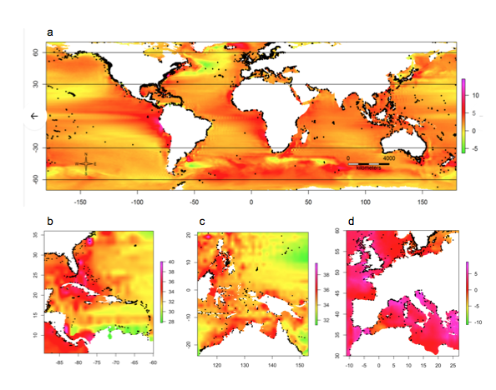

**Figure 1. Patterns of projected ocean warming, 2010–2100.** Changes are SSTs (°C) based on downscaled CIMP3 model outputs under the A2 high-emissions scenario. Black dots indicate the locations (geographic centroids) of MPAs used in the analysis. **a,** Global changes in mean SSTs. **b–c,** Maximum SSTs in 2100 for two tropical regions: **b,** the southwestern Atlantic and **c,** the Coral Triangle. **d**, Changes in maximum SST for one temperate region: the northeastern Atlantic and Mediterranean.

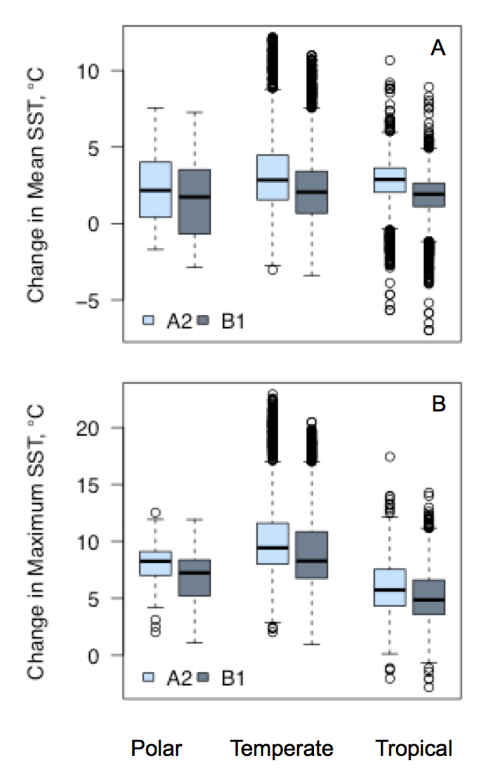

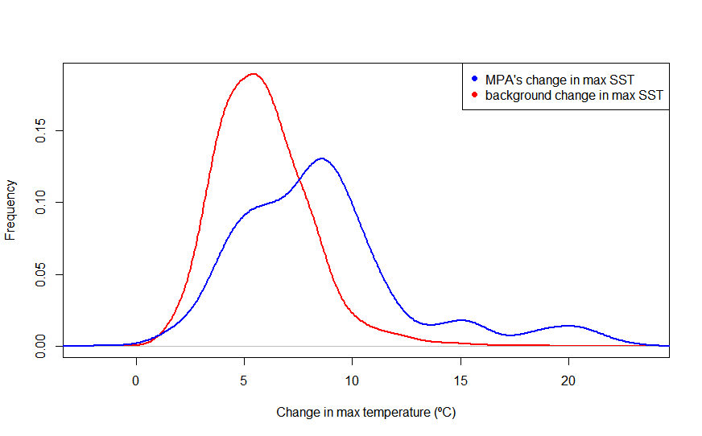

**Figure 2. Predicted ocean surface warming.** Changes in SST by 2100 based on predicted future SSTs from downscaled CIMP3 model outputs in three latitudinal zones under **a,** the IPCC AR4 A2 “business as usual / high emissions” scenario for 8456 MPAs and **b,** the B1 scenario. **c,** Distributions of change (2010–2100, A2) in SST in MPAs (blue line) and at 8456 randomly selected locations (red line). Note the MPAs are clustered near the coasts (see Fig. 1).

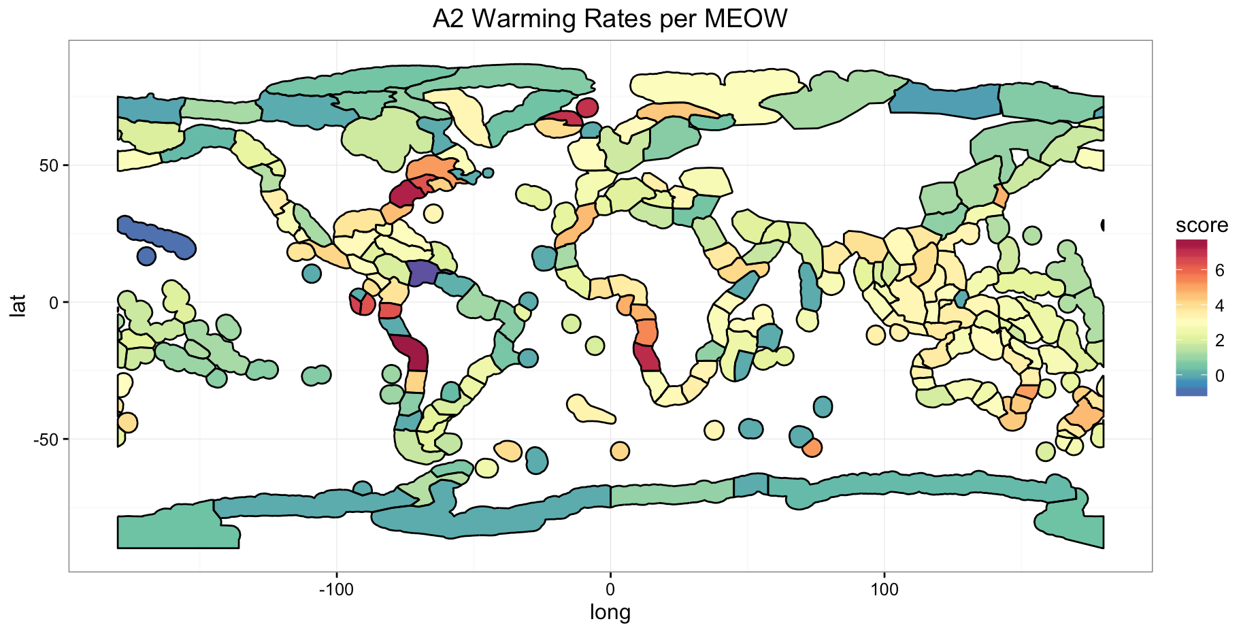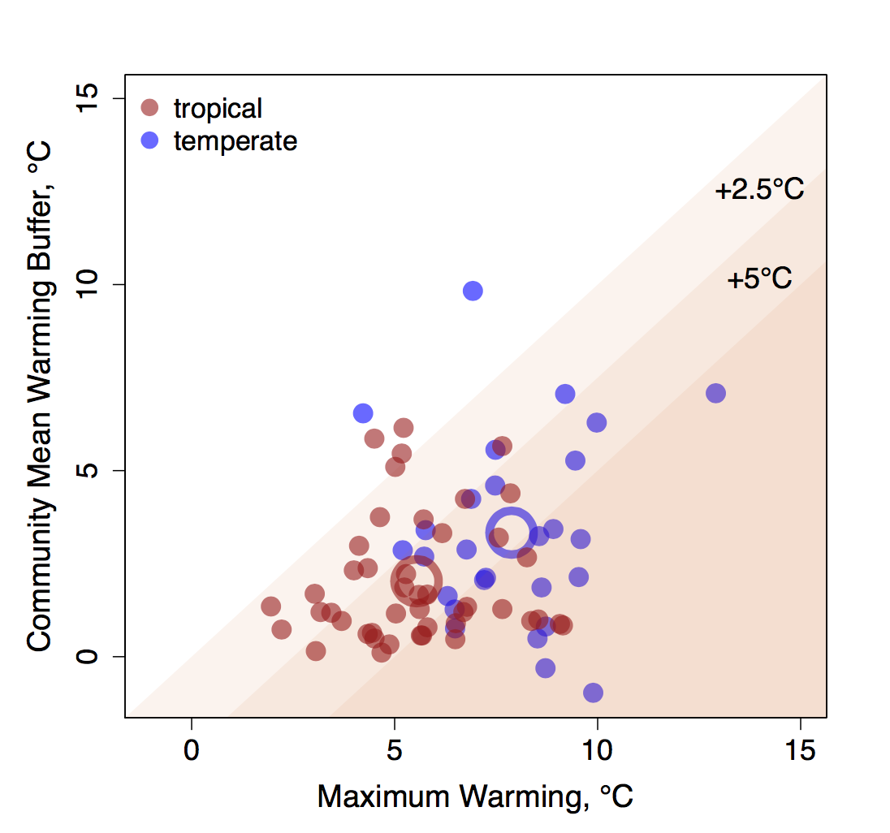

**Figure 3.** **Biodiversity change in marine ecoregions of the world predicted as a function of exposure and sensitivity to warming. top,** Variation in the predicted (A2) increase in maximum SST among ecoregions. Each delineated geographical area is an ecoregion29. Warming rates are the mean of projected rates in MPAs within each ecoregion. **bottom,** A graphical illustration of how the realized effects of predicted increases in maximum MPA SSTs (under scenario A2) in different ecoregions depend on the warming rate (exposure) and ecoregion-specific warming buffer (sensitivity) for reef fishes and mobile invertebrates. Maximum warming is the predicted mean warming rate for all MPAs in each ecoregion (see values in Table S1). The Community Mean Warming Buffer (see complete description in the Supplemental text) is the average maximum temperature across the geographical ranges (determined with 2,447 *in situ* surveys by the Reef Life Survey (RLS) program2) of all species in a community minus the present maximum summertime SST; it is an estimate of how far on average community inhabitants are from their thermal maxima. Each point represents an ecoregion and the larger circles represent mean values for tropical and temperature ecoregions.